**Candidate Guidebook**

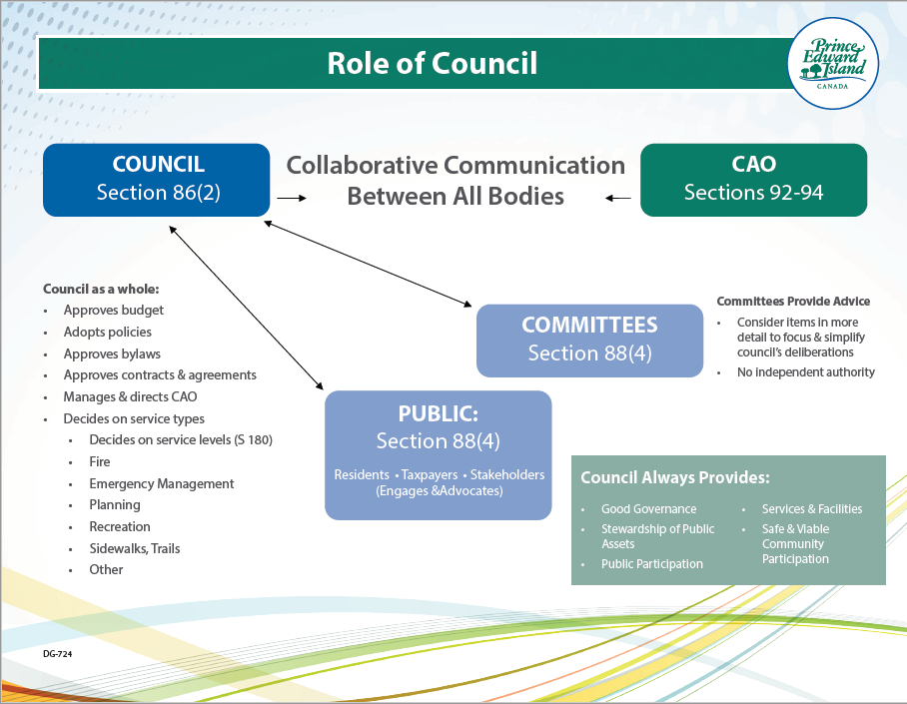

## Who is eligible to be nominated for municipal council?

You can run for municipal office if you*:

* Are a Canadian citizen
* Are at least 18 years of age or older
* Have been ordinarily resident in the municipality for a period of at least six months before the election.

*Different rules apply in the Resort Municipality (see subsections 33(4) and 33(6) of the MGA)

** Municipal, Provincial and Federal employees should talk to their employer before filing nomination papers.

*** Exception to those who can be nominated outlined in MGA s.33.

## Who isn't eligible to be nominated for municipal council or who become ineligible?

*Municipal Government Act - MGA* Section 98

Disqualification of council member

(1) A council member is disqualified from serving on council if the member is appointed or elected as

(a) a judge of the provincial court, the Supreme Court or the Court of Appeal;

(b) a member of Parliament;

(c) a member of the Legislative Assembly; or

(d) a chief or councillor of a First Nation Band in the province. Disqualification - residency

(2) A council member who ceases to be eligible as an elector in the municipality is disqualified from serving on council.

## How to become a candidate for municipal council?

**Step 1** – Attend a council meeting in your municipality.

**Step 2** – Talk to the CAO (Chief Administrative Officer) and/or Council in the municipality to ask questions, such as how many meetings, what projects, what is the council remuneration, etc.?

**Step 3** – Contact your municipality’s Municipal Electoral Officer (MEO) and pick up a nomination form. Find your municipality contact information <https://www.princeedwardisland.ca/municipaldirectory> Ask the MEO if your municipality has ‘at large’ or ‘by ward’ elections.

**Step 4 -** Fill out the nomination form with the appropriate number of qualified electors in the required municipality or ward. Then file with the MEO at a time and place specified by the MEO. Depending on the municipality a deposit may be required.

## What can I expect if I am elected to a municipal council?

The four-year term for those elected will be from December 7th, 2022, to December 6th, 2026. (MGA s.79 (2)) The municipal council that was in place prior to the election will finish their term on December 6th, 2022.

Mayor and councillor:

1. **Time commitment** can range from a few council and committee meetings a month in small rural municipalities to several meetings a week in larger municipalities. There will be files and reports that you are expected to read prior to attending meetings, to allow for informed decision-making. Depending on the municipality, people in the community may contact you – you represent all of them.
2. **Transparency/confidentiality** – Some things are very public, like council meetings, financial statements while other items need to remain confidential (i.e., resident/business information in some cases). In fact, you need to follow the municipality’s access to information and protection of privacy bylaw.
3. **Council creates and follows laws –**Council reviews and approves bylaws. Check the bylaws your municipality has <https://www.princeedwardisland.ca/municipaldirectory> The council must also follow existing legislation and regulations such as the *Municipal Government Act, Planning Act*, *Water and Sewage Act* and many more. A list of provincial acts and regulations can be found here. <https://www.princeedwardisland.ca/en/legislation/all/all/a>
4. **Decision maker –**Council as a whole (team) makes decisions for the municipality such as services and programs to offer, policies to provide direction, reviews/approves bylaws, and financials. The Mayor and Council give policy direction to the CAO. The CAO directs staff and operations.

## How much do I get paid as an elected official?

Wages or honoraria for elected officials differ in each municipality. Council wages and honoraria must be set out through municipal bylaw. Contact your municipality for more information. Check the municipal directory <https://www.princeedwardisland.ca/municipaldirectory> to see if they have a remuneration bylaw.

A mayor (*MGA*s. 89):

* **Power** – **Mayors in Prince Edward Island have limited authority** and role. *(See the role of council diagram for more information.)*Mayors only vote to break a tie. The council makes **decisions as a whole or team** and follows a strong council model.
* **Spokesperson***–*you are the public face of the municipality.
* **Signing Authority, Chair of council meetings, and appoints Deputy Mayor.**

**Resources:**

* Roles and responsibilities video overview <https://youtu.be/p3Mmg_kbYsg>
* New municipal councillor – now what? <https://youtu.be/-ULpafg4LSQ>

## Why become a candidate for municipal council?

Benefits:

* + helping the community;
  + being part of the decision-making process;
  + providing your expertise; and,
  + remuneration in some cases (varies by municipality).

Municipal Councillor quote, *“The role of councillor is challenging, it carries enormous responsibility, but is endlessly fascinating. I have learned the importance of putting aside opinion and bias in favour of facts and legal guidelines, even when that means a decision may be unpopular.”*[***[1]***](https://peimunicipalelections.ca/candidate-guidebook#_ftn1)

## What do I need to know about campaigning?

Every municipality has an election bylaw and within that bylaw campaigning rules are outlined. For example:

* How much can be spent on election campaigning?
* Who can contribute to an election campaign and what are the limits?
* What are the disclosure requirements in respect of campaign contributions?
* Provincial or municipal rules on signage. (size, cost, placement, timing)
  + *Highway Signage Act Regulations* – Election signs are not erected, displayed, maintained or placed more than one month before the date of a municipal election.  And the sign shall be removed within seven days after the election. (*Highway Signage Act Regulations*section 3.1 (1) (b) and section 3.1 (2))
  + City of Charlottetown bylaw includes the above plus a requirement that the sign can be up to a maximum Sign Area of 3sq m (32.3sq ft). <https://www.charlottetown.ca/resident_services/bylaws_regulations/signage_regulations>

For more information ask the MEO – Municipal Electoral Officer or your municipality for the election bylaw. Municipal election regulations can be found here <https://www.princeedwardisland.ca/sites/default/files/legislation/m12-1-3-municipal_government_act_municipal_election_regulations.pdf>

**Candidate’s Agent**

Candidates can appoint an agent to act on their behalf by completing the required form provided by the Municipal Electoral Officer – MEO.  Refer to *Municipal Government Act – MGA* section 35 for more information.

**Additional resources for women seeking office:**

* [This page will be updated with resources on diversity.](https://peimunicipalelections.ca/diversityresources)
* [PEI Coalition for Women in Government](https://www.peiwomeningovernment.ca/)
* [Elections PEI – Women in Politics](https://www.electionspei.ca/sites/www.electionspei.ca/files/PEICoalitionforWomeninGovernment_1921_2020.pdf)
* [PEI Advisory Council on the Status of Women](http://peistatusofwomen.ca/) - Promoting equality and advising government on legislation, policy and programs.

## Reasons not to run for municipal council.

1. Do not run for only one issue, since most new council members find that municipal government’s power is limited and often the issue is a provincial or federal responsibility.
2. You do not have the time commitment to review materials to make informed decisions for municipal matters.
3. You see yourself as a volunteer who wants to do the work of staff rather than policy decision making. The *Municipal Government Act* – MGA limits the council’s role in section 92, Prohibition – employment of members.

## What are election offences?

The *Municipal Government Act* Division 14 (page 42) – Election Offences outlines the proper behavior during municipal elections and includes:

* voting offences or fraudulent activities
* submitting false nominations papers
* intimidation and bribery of voters (directly or indirectly)
* ballot and ballot box offences
* disobeying regulations
* offences by an election official

**Penalties**

Committing an election offence can result in penalties that are listed in MGA Division 15 (pg. 44):

* **Fine, imprisonment** (conviction of a fine not exceeding $2,000 or imprisonment for a term not exceeding two years, or to both a fine and imprisonment.)
* **Forfeit, disqualification**(member’s seat on the council and is disqualified from being a candidate at any municipal election held in the five years after the commission of the offence.)
* **Disqualification**(being a candidate for nomination or election as a mayor or councillor at any municipal election held in the five years after the commission of the offence.)

## Post-Election First Steps

Your MEO and/or CAO will walk you through the steps after election. Here are a few key items:

* Forms:
  + All candidates must complete a Disclosure Statement of Campaign Contributions and Election Expenses Municipal Election Campaigns  <https://www.princeedwardisland.ca/en/information/fisheries-and-communities/municipal-election-campaigns>
  + Successful candidates complete a Municipal Oath of Office (MGA s. 79 (1)) Dec. 1-7.
  + Successful candidates also complete and file with the CAO of the municipality Council Member Disclosure Statement Form (Yearly reporting of council member November each year is required.)
* Information and Resources
  + Check out the municipality’s bylaws, policies, minutes, and any other information provided by the CAO of the municipality.
  + Review the *Municipal Government Act – MGA* and its regulations <https://www.princeedwardisland.ca/en/information/fisheries-and-communities/municipal-government-act-and-regulations>
  + Review of the Local Government Resource Handbook <https://www.princeedwardisland.ca/en/publication/local-government-resource-handbook> for an overview of how a municipality functions and the general roles and responsibilities of a municipal council.
  + Review Learning Resources <https://www.princeedwardisland.ca/en/topic/training-for-municipalities>

[[1]](https://peimunicipalelections.ca/candidate-guidebook#_ftnref1) <https://journalletour.com/municipal-councillor/>