​

**MUNICIPAL ELECTION OFFENCES FAQ**

**What is an election offence?**

An election offence is a violation of the rules in place that govern the election. An offence could be anything that violates the Municipal Government Act, your municipality’s Elections Bylaw, or your municipality’s Campaign Contributions and Elections Expenses Bylaw.

​

​​

​

**Where can I find the rules for elections?**

You can find the rules for elections in the *Municipal Government Act, the Municipal Election Regulations, Campaign Contributions and Elections Expenses Bylaw Regulations*, and your municipality’s Elections Bylaw and Campaign Contributions and Elections Expenses Bylaw.

Rules specific to elections offences can be found under division 14 – Election Offences (sections 67 to 71), in the *Municipal Government Act*.

Elections Bylaws may vary from one municipality to another. For example, some municipalities have set their campaign spending limit at $1 or less – in these municipalities you would be committing an election offence if you spent above the limit set in their Bylaw. For more information on your municipality’s Elections Bylaw and Campaign Contributions and Expenses Bylaw you should [contact your municipality.](https://www.princeedwardisland.ca/en/feature/municipal-directory#/service/MunicipalDirectory/MunicipalityLookUpSearch)  

**Who can commit an election offence?**

Candidates, their agents, election officials, and even voters (electors) can all be found to have committed an election offence!

* Candidates can commit election offences if they falsify their nomination paper, if they leave contributions off their disclosure statement, or if they are threatening or intimidating voters.
* Candidates’ agents can commit election offences if they interfere with voters while they are voting, or by touching the ballots during a recount.
* Election officials can commit election offences when they neglect their responsibilities, or if they mark ballots they aren’t supposed to.
* Voters (electors) can commit election offences if they sign a nomination form, they are not eligible to sign, if they vote in an election they are not eligible to vote in, or if they make a false statement/declaration of residency in order to vote.

**What are the penalties for an election offence?**

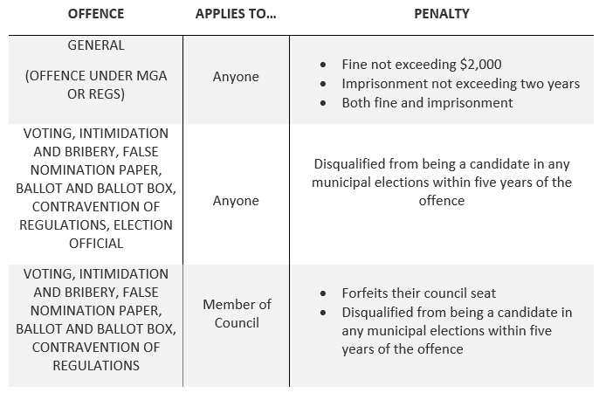Depending on if you are a candidate, a council member, an election official or an elector, there are different penalties for committing an election offence:

*Note: Penalties may vary by municipality, for more information please* [*contact your municipality*](https://www.princeedwardisland.ca/en/feature/municipal-directory#/service/MunicipalDirectory/MunicipalityLookUpSearch) *or check your municipality’s Elections Bylaw.*

​

**What do I do if I suspect someone of committing an election offence?**

If you have concerns related to potential election offences, you should bring it to the attention of your [municipality’s municipal electoral officer (MEO).](https://peimunicipalelections.ca/list-of-municipal-electoral-officers)

If you are an elector and are concerned about a candidate’s disclosure statement; you may make a complaint in writing and deliver it to the MEO or the chief administrative officer (if the MEO is no longer appointed).

**How can I avoid committing an election offence?**

The best way to avoid making an election offence is to familiarize yourself with the rules, be truthful, and know what your responsibilities are as either a candidate, an agent, a voter or an election official!

​